Overview of Inertial Force Research
【author】
[Content Summary]
Disc A, with its center passing through the origin, is uniformly and symmetrically rotating within the x, y plane at a speed of V3 (1 kilo-revolution per second). At the beginning of the experiment, a force with a direction parallel to the Z axis and perpendicular to the x, y axes is applied directly above the Z axis to rotate the upper half of the disc around the x axis in the positive direction of the Z axis, while the lower half rotates in the negative direction of the Z axis. After rotating at a 45-degree angle, it stops (due to the gyroscopic effect, there is a tendency to return to the original state, requiring external force to fix it). Disc B (when the rotational speed is zero, a force with a direction parallel to the Z axis and perpendicular to the x, y axes is applied directly above the Z axis to first rotate the upper half of the disc around the x axis in the positive direction of the Z axis, while the lower half rotates in the negative direction of the Z axis. After rotating at a 45-degree angle, it stops, and then begins to accelerate and rotate to a speed of V3 and maintain it.) The observed and measured motion states of the two discs are exactly the same, but the gyroscopic effect determines and confirms that their actual motion states must be different。
Keywords: centrifugal force; Gravitational force and other effects; Accelerometer; object of reference.
【text】

High school physics question: When a bus is accelerating forward at 9.8 meters per second ^ 2, use a 50 centimeter long rope to hang a small iron ball on the top of the bus (which can be seen as a simple accelerometer. When balanced, each rope's backward angle with the roof corresponds to a certain acceleration, and the rope can never reach absolute level. When the acceleration is too large, the rope will break). When the rope maintains a certain angle with the roof, how many degrees can the small iron ball remain stable? The answer is a 45 degree angle. The small iron ball is a stable balance system. At this point, if the heavy ball is pulled away from the balance position within the vertical plane where the rope is located, the maximum angle is 5 degrees. After releasing it, the heavy ball will oscillate back and forth around the 45 degree angle balance position, performing a pendulum motion with a shorter period than when there is no horizontal acceleration (T=2 π√ (L/g)). According to Einstein's principle of equivalence, it is impossible to distinguish between the gravitational force generated by gravity and the horizontal acceleration a. When the bus accelerates horizontally at 9.8 meters per second ^ 2 forward, the potential energy of the small iron ball deviating from the equilibrium position by a maximum angle of 5 degrees is greater than the potential energy of the small iron ball deviating from the equilibrium position by a maximum angle of 5 degrees when it is stationary. The additional potential energy is equivalent to gravitational equipotential force potential energy and gravitational potential energy, which cannot be distinguished (more important in energy analysis when the gyroscope deviates from the equilibrium position at high speed).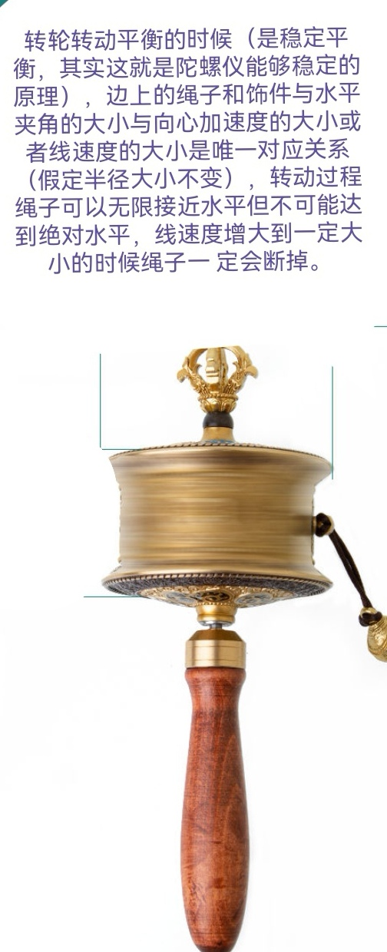
diagram A
When the wheel in Figure A rotates and balances, the angle between the rope and the ornament and the horizontal is a stable balance. The angle between the rope and the ornament on the edge and the horizontal is the only corresponding relationship with the magnitude of the centripetal acceleration or linear velocity. During the rotation process, the rope can approach the horizontal infinitely but cannot reach absolute horizontal. When the linear velocity increases to a certain level, the rope will definitely break.
When the wheel rotates at high speed and is in equilibrium, the ropes and accessories on the side are in stable balance. At this time, if the heavy ball is pulled away from the equilibrium position within the moving vertical plane where the rope is located, with an angle of less than 10 °, and the heavy ball oscillates back and forth after releasing it, the rope and accessories in the moving vertical plane where the rope is located (in non inertial coordinates) are typical pendulum devices (also according to Einstein's equivalence principle, it is impossible to distinguish the equal force of gravity and acceleration (centrifugal force). ）A wooden turntable is formed by symmetrically installing a large number of solid wood chips instead of ropes around the central axis of the wheel. A gyroscope is made by installing a large number of wooden turntables up and down around the central axis of the wheel.
When the gyroscope rotates at high speed and is balanced, each rotating particle inside the gyroscope can be seen as a rope and ornament on the edge of the wheel when it rotates at high speed and is balanced.
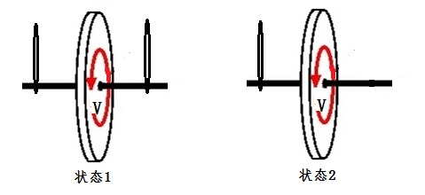
Figure 1
In Figure 1, the plane where the disk in state 1 is located is the x and y planes. When the velocity V is zero and the hanging rope on the right side is cut, the disk will hang down under the action of gravity. When the speed V of the disk in state 1 of Figure 1 accelerates to 1 kilorevolutions per second, the hanging rope on the right side is cut off, and the disk side will not sag under the action of gravity, as in state 2 (the part of the disk above the horizontal line passing through the center of the circle will tilt to the right (sometimes obvious, sometimes slightly deformed), and the part below the horizontal line passing through the center of the circle will tilt to the left. The tilt angle of the disk is determined by the weight of the disk and the size of the gyroscopic effect). Objectively speaking, the torque generated by the gravity of the disk has always existed. In state 2, the disk has not hung down. According to the balance condition of the force, it can be proved that there must be a torque that is equal in magnitude and opposite in direction to the gravity torque.
Disk state 2 is due to the gyroscopic effect not hanging down. The result of the gyroscopic effect is that state 2 generates a moment that is equal in magnitude to the gravitational moment and opposite in direction. Based on the equilibrium conditions, the direction of the centrifugal force can be calculated using the vector rule and equilibrium conditions, taking into account the measurable angle at which the disk tilts to the right (sometimes slightly deformed) above the horizontal line passing through the center of the circle, the magnitude of the centrifugal force, and the magnitude of gravity.
Practice has proven that after cutting the hanging rope on the right side of the disk, the disk will slightly move downwards (the part of the disk above the horizontal line of the center of the circle tilts to the right, and the part below the horizontal line of the center of the circle tilts to the left). Practice (the application of gyroscopes) has confirmed that the centrifugal force (inertial force) generated by all particles above the horizontal line of the center of the circle (excluding the horizontal line of the center of the circle) on the high-speed rotating disk after tilting is equal to the force of gravity (without an object applying force) or perpendicular to Z Axis wise, all particles in the upper half of the disk generate a horizontal leftward moment (moment is a vector) relative to the horizontal line passing through the center of the circle (actual value can be obtained through integration calculation) (there are also forward and backward moments, which are symmetrical and opposite in direction due to equal magnitude and cancellation). After tilting, the centrifugal force (inertial force) generated by all particles in the lower half of the disk passing through the horizontal line of the center of the circle (excluding the horizontal line passing through the center of the circle) will generate a horizontal rightward moment relative to the horizontal line passing through the center of the circle for all particles in the lower half of the disk (actual value can also be obtained through integration calculation), and the rotating moment formed by the disk with the horizontal line passing through the center of the circle as the rotation axis is manifested as the gyroscopic effect (not fully recovered due to the influence of gravity). initial state), The part above the horizontal line of the center of the disk tilts to the right (sometimes obvious, sometimes slightly deformed), and the part below the horizontal line of the center of the disk tilts to the left. The specific tilt angle of the disk is determined by the weight of the disk and the size of the gyroscopic effect before cutting, achieving the use of gyroscopic effect to generate rotational torque (which must be an external force torque, the effect of external force has no external force object) to counteract the torque generated by gravity, keeping the disk from hanging down. The gyroscopic effect of the disk ultimately generates a counterclockwise torque with the contact point between the left hanging rope and the left horizontal axis as the fulcrum (the torque is not affected by time, and the size of the right tilt angle is determined by the speed of the hanging rope on the right side of the disk before cutting) to counteract the downward clockwise torque generated by gravity. If the velocity V of the disk is very low, the centrifugal force generated by the disk, i.e. the force of gravity, produces the maximum upward torque (when the disk is in contact with x, y) When the plane angle approaches infinitely close to 90 degrees (when the angle is equal to 90 degrees, the state is in a chaotic state, which is a typical real-life case of Schr ö dinger's cat, with the highest entropy value), the isolated gyroscope system deviates from 90 degrees. Without external interference, the degree of chaos will not increase with time, and it will automatically accelerate towards the initial stable equilibrium state (the total angular momentum of the closed gyroscope system increases when it is not affected by external torque). In the moment it returns to the initial equilibrium position, the kinetic energy formed by the recovery process quickly disappears (the angular momentum formed by the recovery process of the closed gyroscope system quickly disappears when it is not affected by external torque, which is commonly recognized as the gyroscope effect, and can be observed repeatedly, referring to automatic observation). Flip top toy, further research needed, maximum torque. The smaller the angle, the smaller the torque. The direction and magnitude of the torque during the entire process are independent of whether the disk rotates clockwise or counterclockwise. The torque direction generated by the opposite rotation direction of the disk is the same, which is inconsistent with the definition of angular momentum vector direction. Following practice (Case 1) is the only criterion for testing truth. When the maximum upward torque generated by centrifugal force is less than or equal to the downward torque generated by gravity, the disc will hang down. Increasing the rotational speed of the disc after it hangs down produces the gyroscopic effect, which is different from the gyroscopic effect produced by the speed when the hanging rope on the right side of the disc is cut off.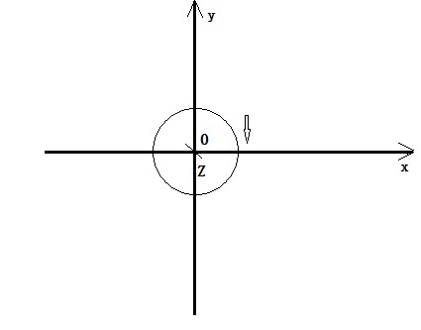
Figure 2
The theoretical proof is as follows:
Figure 2: The Z-axis passes through the origin and is perpendicular to the x and y axes. The center of the disk is at the origin, and the disk is uniformly symmetrical in the x and y planes. The high-speed rotation speed of all particles on the disk is V3. The velocity of all particles on the disk is only the x-axis and y-axis components, and the z-axis velocity component is 0. At the beginning of the experiment, a force parallel to the Z-axis and perpendicular to the x and y axes is applied directly above the z-axis to make the upper half of the disk revolve around the positive direction of the x-axis and the negative direction of the z-axis. After rotating at a 45 degree angle, it stops (due to the gyroscope effect, there is a tendency to return to the original state, which needs to be fixed with external force, and the process has an energy storage effect, similar to the upward movement of a pendulum). There is only displacement in the z-axis direction, and there is no velocity in the z-axis direction after the movement is completed, that is, the result of integrating t with ∆ v in the z-axis direction is 0. The direction is parallel to the Z axis and perpendicular to the x and y axes. The force acting perpendicular to the x and y axes cannot change the magnitude and direction of the angular velocity component, similar to the process of flat throwing motion. The effect of gravity cannot change the magnitude of the horizontal component v.
The experiment begins by applying a force parallel to the Z-axis and perpendicular to the x and y axes directly above the z-axis, causing the upper half of the high-speed rotating disk to rotate around the positive direction of the x-axis and z-axis, and the lower half to rotate 45 degrees towards the negative direction of the z-axis before stopping (due to the gyroscopic effect, there is a tendency to return to its original state, which requires external force fixation). During the process of rotating the upper half of the disk by 45 degrees in the positive direction of the x-axis and z-axis, there is only velocity in the z-axis direction during the rotation time. After rotating the upper half of the disk by 45 degrees in the positive direction of the x-axis and z-axis, the lower half stops rotating by 45 degrees in the negative direction of the z-axis (due to the gyroscope effect, there is a tendency to return to the original state, which needs to be fixed with external force). The velocity in the z-axis direction of each particle on the disk is zero, that is, the z-axis direction ∆ v=at is integrated with t to obtain the result of ∆ v as 0. According to the vector rule, a high-speed rotating disk is applied with a force parallel to the Z-axis and perpendicular to the x and y axes, directly above the z-axis. The upper half of the disk rotates around the positive direction of the x-axis and the negative direction of the z-axis by 45 degrees before stopping (due to the gyroscope effect, there is a tendency to return to its original state, which requires external force to fix it, and the motion change is only the appearance. The force behind the appearance is the essence, which is the focus of research). When the center of the initial high-speed rotating disk is at the origin, the velocity and direction of each particle on the x-axis and y-axis are the same when the entire disk rotates at high speed in the x and y planes (the object moves a finite distance in a finite time, only changing the spatial position of the object, not the velocity and direction of the object). The upper part of the disc rotates 45 degrees around the positive direction of the x-axis and z-axis, and then stops. In the x, y, and z-axis directions, ∆ v=at respectively, t The integration results in ∆ v being 0, and the direction of centrifugal force should also be the same as when the disk rotates at high speed in the x and y planes before rotation. This has been proven to be correct in the extensive practical application of gyroscopes. At this point, the disk undergoes displacement per unit time in the z-axis direction, but the velocity is zero (the integration results in a ∆ v value of zero, which contradicts Newton's law if the velocity is not zero). The particle has circular motion in the x and z planes, but the angular momentum around the y-axis is zero (if the z-axis velocity is not zero or the angular momentum around the y-axis is not zero, there will be no gyroscopic effect, and the same conclusion as in Figure 3 will be obtained, which is inconsistent with the facts). The relationship between time, speed, and displacement needs further research. Figure 2: The high-speed rotating disk rotates in a direction parallel to the Z-axis and perpendicular to the x and y axes, with the upper half rotating 45 degrees around the positive direction of the x-axis and z-axis, and the lower half rotating 45 degrees around the negative direction of the x-axis and z-axis before stopping (due to the gyroscopic effect, there is a tendency to return to its original state, which requires external force fixation). All particles on the disk still have a centrifugal force perpendicular to the z-axis. Consistent with practice, centrifugal force is perpendicular to the z-axis and x-axis, forming a force arm. At this point, a torque is generated (the torque is not affected by time, so state 2 in Figure 1 can be maintained). The integration results in a partial torque of 45 degrees between the upper half of the disk and the x and z planes in the negative z-axis direction (the total torque is always perpendicular to the x-axis), and the lower half of the disk is a partial torque of 45 degrees between the disk and the x and z planes in the positive z-axis direction (the total torque is always perpendicular to the x-axis). The overall disk forms a torque with the x-axis as the fulcrum (the maximum torque occurs when the disk is infinitely close to 90 degrees from the x and y planes). The smaller the angle, the smaller the torque. ）To restore the high-speed rotating disk to its initial state and return to the x and y planes while maintaining its axis pointing in a relatively fixed z-axis direction (the process has an energy storage release effect, similar to the downward movement of a pendulum). The above conclusion can be verified as correct on all gyroscopes, and theory and practice can mutually verify each other.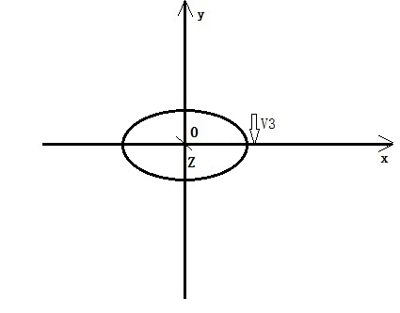
Figure 3
Figure 3 shows the Z-axis passing through the origin perpendicular to the x and y-axis outward, with the center of the disk at the origin. The disk is uniformly symmetrical in the x and y planes and rotates at a speed of 0. At the beginning of the experiment, the upper half of the disk (with a speed of 0) is first rotated around the positive direction of the x axis and z axis (outward), and the lower half is rotated towards the negative direction of the z axis (inward). After rotating at a 45 degree angle, it stops (without gyroscopic effect, there is no energy storage effect during the rotation process), and then accelerates to rotate at a speed of V3 and maintains it (without gyroscopic effect, no external force is required to fix it). At this time, the gyroscopic effect will not cause the disk to quickly return to the x and y planes and maintain its axis pointing.
The center of the disk in Figure 2 is at the origin, and the disk is uniformly symmetrical in the x and y planes with a rotational speed of V3. At the beginning of the experiment, a force parallel to the Z axis and perpendicular to the x and y axes is used to rotate the upper half of the disk in the positive direction of the x and z axes, and the lower half in the negative direction of the z axis. After rotating it for 45 degrees, it stops (due to the tendency of the gyro effect to return to its original state, external force is needed to fix it) (with gyro effect, there is energy storage effect during the rotation process, similar to rotating a door with a ground spring). At this time, the disk in Figure 2 and Figure 3 (first rotate the upper half of the disk in the positive direction of the x axis and z axis, and the lower half in the negative direction of the z axis, rotate it for 45 degrees, and Accelerate the rotation to a speed of V3 and maintain it. ）The observation and measurement results of the instantaneous motion state of the two are exactly the same, but the presence or absence of the gyroscopic effect determines and confirms that the motion state of the two is definitely different (which fully proves that the definitions of time, velocity, and displacement in physics are imperfect). If the fixed external force in Figure 2 is revoked at this time, the disk will accelerate and rotate around the X-axis, and the angular momentum around the X-axis will increase (similar to the automatic closing effect of a door with a spring on the ground). According to the conservation of angular momentum, it can be inferred that the disk must be subjected to a moment around the X-axis (the moment is maximum when the angle between the disk and the x and y planes is infinitely close to 90 degrees). The smaller the angle, the smaller the torque. ）Consistent with practice. Before returning to the x and y planes, the disk is accelerating and rotating around the X axis (according to the conservation of angular momentum, it is known that there must be an external torque). The smaller the angle between the disk and the x and y planes, the smaller the rotation acceleration (the smaller the external torque). The disk stops accelerating and rotating around the X axis until it is about to coincide with the x and y planes (there is no external torque), but the angular velocity is the highest (the semicircles on both sides of the X axis are separately integrated with the angular momentum on the X axis, and the result is not zero, resulting in equal sizes and opposite directions on both sides, producing the effect of restoring the initial balance state of the gyroscope, that is, the fixed axis performance of the gyroscope. When the semicircles on both sides of the X axis rotate at high speed within a range of less than 90 degrees, the angular momentum on both The momentum integral value does not change due to rotation, and it is an objective existence that can be repeatedly verified at a special moment equal to 90 degrees. The entire disk is separated or the whole is X The angular momentum integrated by the axis is zero. In practice, due to the fixed axis, the kinetic energy formed by the angular velocity around the X-axis as the axis will disappear instantly when the gyroscope automatically returns to its initial upright equilibrium state. ）The angular velocity of an object cannot jump, and the kinetic energy cannot disappear. In this case, the disk should perform a quasi pendulum motion (the direction in which the pendulum finally stops (i.e. returns to its initial state due to the gyroscopic effect) is determined by the direction of the external force acting on the pendulum. Similarly, it can be calculated that the disk rotates at high speed on the Z-axis before rotating around the X-axis, and the centrifugal force direction of the disk remains perpendicular to the z-axis after rotating around the X-axis). In practice, when the disk speed is low, it will perform quasi pendulum motion. When the disk speed is high, it will not perform quasi pendulum motion. When it returns to its initial equilibrium position, the rotational kinetic energy around the X-axis that corrects the imbalance will disappear instantly. The pendulum motion ends. A gyroscope with a large gyroscopic effect can only complete less than 1/4 of the pendulum motion, while a gyroscope with a large gyroscopic effect can perform X The period of a pendulum motion with an axis as the axis is very small, and it stops after completing less than 1/4 of the pendulum motion, achieving good navigation effect. Continuous reciprocating oscillation is not conducive to navigation. In practical applications, the gyroscope does not experience continuous reciprocating oscillation, and the navigation effect is very good. When it returns to the initial equilibrium position, the kinetic energy recovered by rotation around the X-axis disappears instantly.
The period of a pendulum is related to its length and the local gravitational acceleration (which cannot be changed). The restoring force of a pendulum is the component of gravity acting along the tangent direction of the arc and pointing towards the equilibrium position. The larger the deflection angle, the greater the restoring force and acceleration (0-90 degrees, including 90 degrees).
The size of the gyroscopic effect is related to the radius (equivalent to pendulum length) and linear velocity (which determines the centripetal acceleration a similar to gravity g). In order for a gyroscope to return to its equilibrium position, there must be an external force or external force component pointing towards the equilibrium position during the process (external force is the only factor that changes the size and direction of the object's motion state). The larger the deflection angle, the greater the restoring force and acceleration (0-90 degrees, excluding 90 degrees). With the help of Einstein's equivalence principle, centrifugal force (also known as inertial force, can refer to the definition of centrifugal force) is recognized as an external force equivalent to gravity (the magnitude can be changed, there is no object applying force), and the study of factors affecting the gyroscopic effect can fully refer to the working principle of a pendulum.
Appendix:
In the game, an egg can stand vertically with care, but it will fall down when slightly disturbed by external forces, which is unstable balance. Now, let's assume that if all the liquid inside the egg is taken out and a gyroscope is erected inside the egg shell, the upper and lower ends of the gyroscope's axis are fixed to the egg shell. If the egg shell is erected first, then the gyroscope is started at high speed. While the gyroscope inside the egg shell is rotating at high speed (with the same speed), a horizontal disturbance force is given to the right side at the top of the egg shell, causing the egg shell to fall horizontally to the right (without movement). According to the gyroscope effect, the experimental results of the egg shell and gyroscope can automatically restore their upright state, which can be verified by repeated experiments. However, when the egg shell and gyroscope automatically restore their upright state, During the process of standing upright, The overall center of gravity of the eggshell and gyroscope increases, and the potential energy increases. Therefore, there must be external forces such as gravity and support to do work on the eggshell. If there is no external force to do work on the eggshell, it violates the conservation of angular momentum, Newton's second law, and energy conservation. It is somewhat difficult to install a gyroscope inside the eggshell, but there are now gyro toys with external frames available online that can completely replace this experiment. Through practical verification, it has been found that the gyroscopic effect does violate the conservation of angular momentum on the surface, as well as Newton's second law of energy conservation, which states that when an upright gyroscope deviates from its equilibrium position and does work on the gyroscope and its external frame without gravity or support, the potential energy of the external frame will automatically increase. The magnitude of the angular momentum of the external frame around the horizontal axis cannot be changed by a small external force due to the presence of an upright high-speed gyroscope inside, which violates the law of velocity vector synthesis.
The utility of a gyroscope determines the change in angular momentum around the X-axis during the rotational motion of a spherical steel body at a fixed point (where the spherical steel body coincides with the origin), which is not only determined by the external torque and rigid body mass of the X-axis rotation, but also by the magnitude of the angular momentum of the Y-axis and Z-axis rotation (with the presence of gravitational effects such as centripetal acceleration). Due to the gyroscopic effect, the combined velocity of X-axis rotation, Y-axis rotation, and Z-axis rotation in the rotational motion of a fixed-point steel body no longer conforms to the vector synthesis rule.

